Course: CSE 204 – Computer Networks
LAB 4 – Switch Configuration
Due date: May 14th, 2025

Student name | Nguyen Xuan Huan
Student ID | 2131200077

Goal
- Understanding Switch
- Use basic commands of Cisco switch
- Understanding how to configure VLAN on Switch

Assignment list
II.1 Basic Switch Configuration
  - Connect to Switch
- Connect PC to Switch using Ethernet Cable
- Connect a Laptop to configure Switch using Console cable
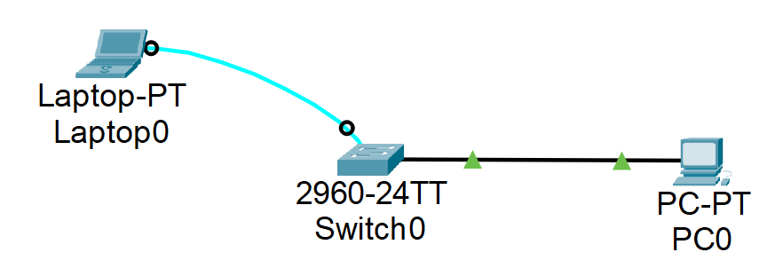
- On Laptop, go to tab Desktop and open Terminal app.

- Execute the following commands:
- Switch> enable
- Switch# erase startup-config
- Switch# reload
- Result:
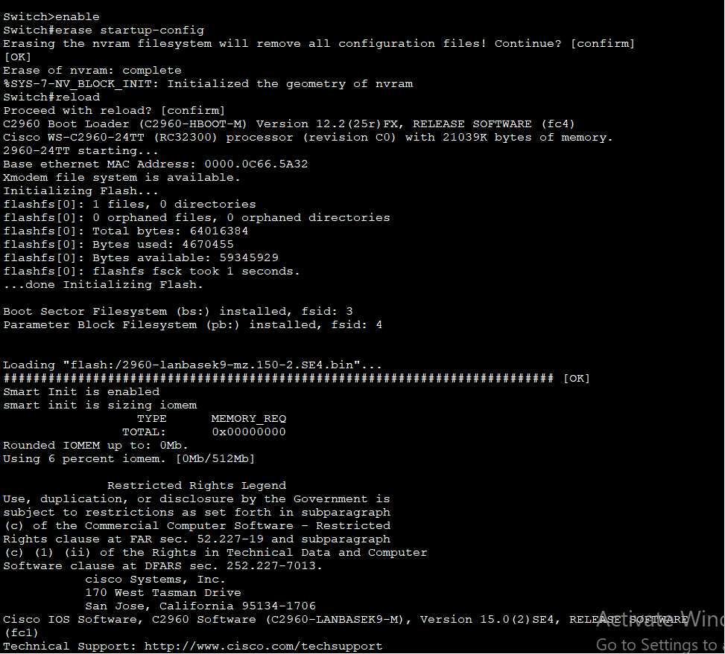
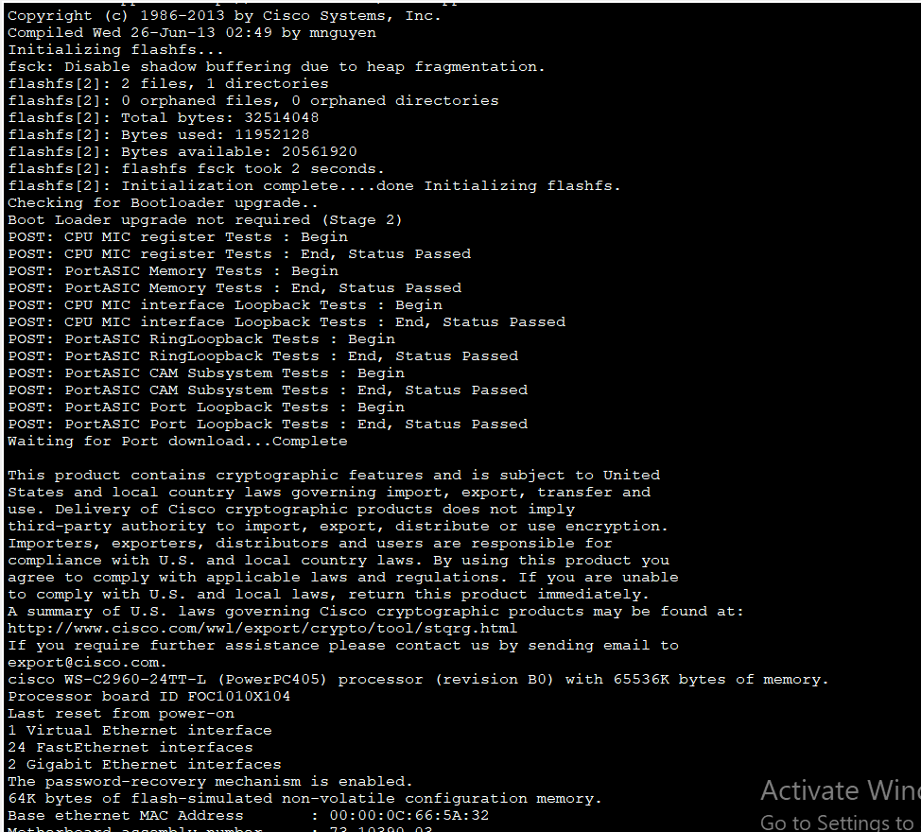
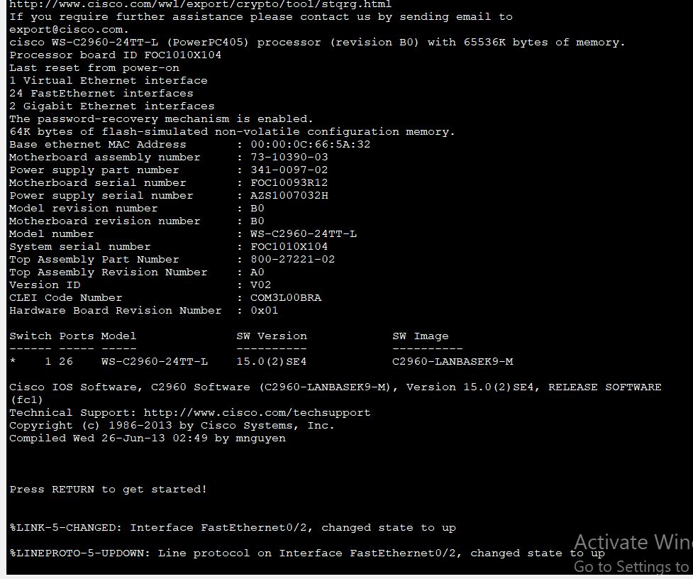

  - Check Switch configuration
- Execute the following command:
  - Switch# show running-config
  - Result:
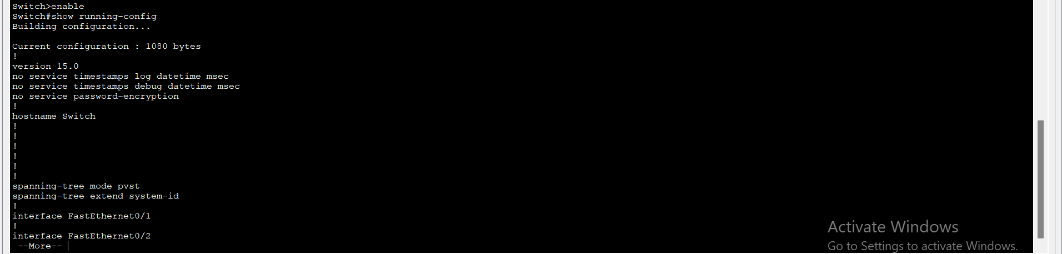

- Cisco Switch has default interface vlan1 as follows:
  - Switch# show interface vlan1
  - Result:
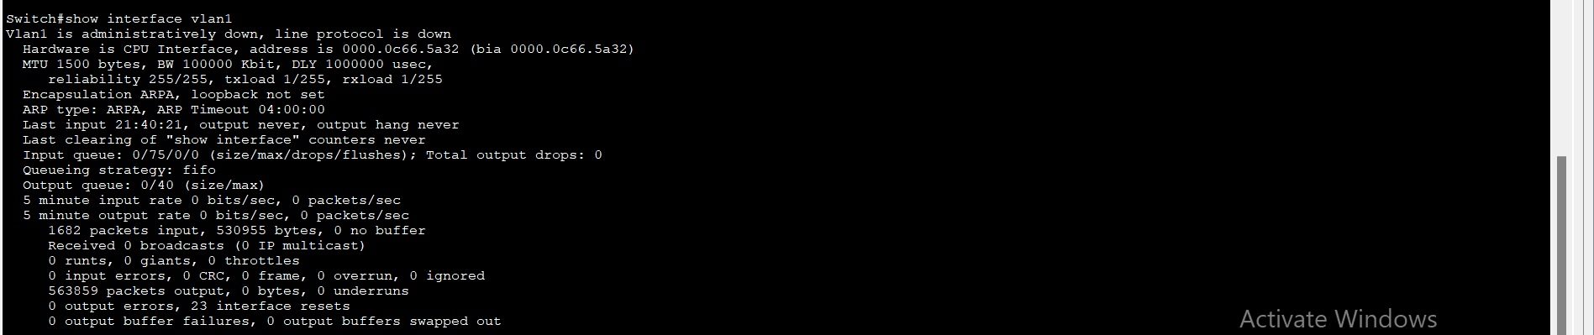

- Check information of IP address, MAC address of interface
  - Switch# show interface fa0/1
  - Result:
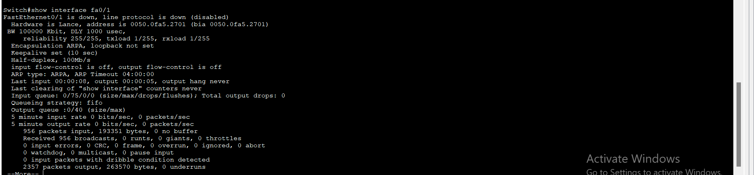

- Check information of OS, RAM, Flash, Memory:
- Switch# show version
- Result:
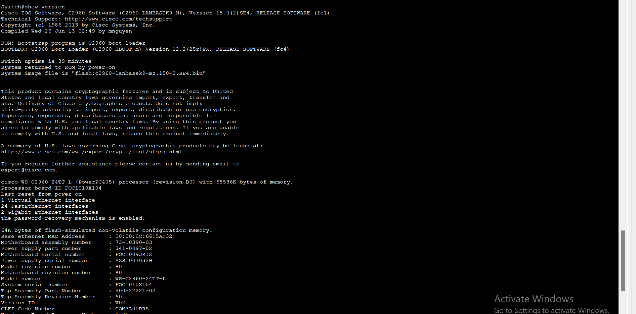
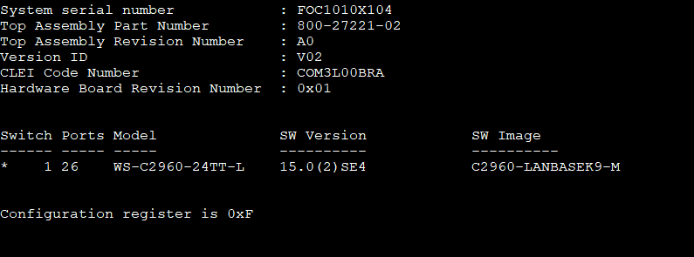
- Switch# show flash
- Result:
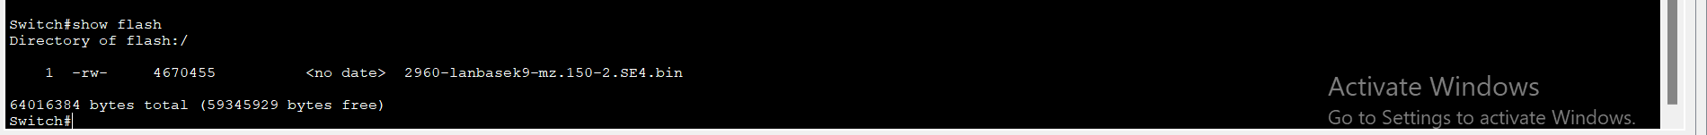

- Check startup configuration
- Switch# show startup-config
- Result:
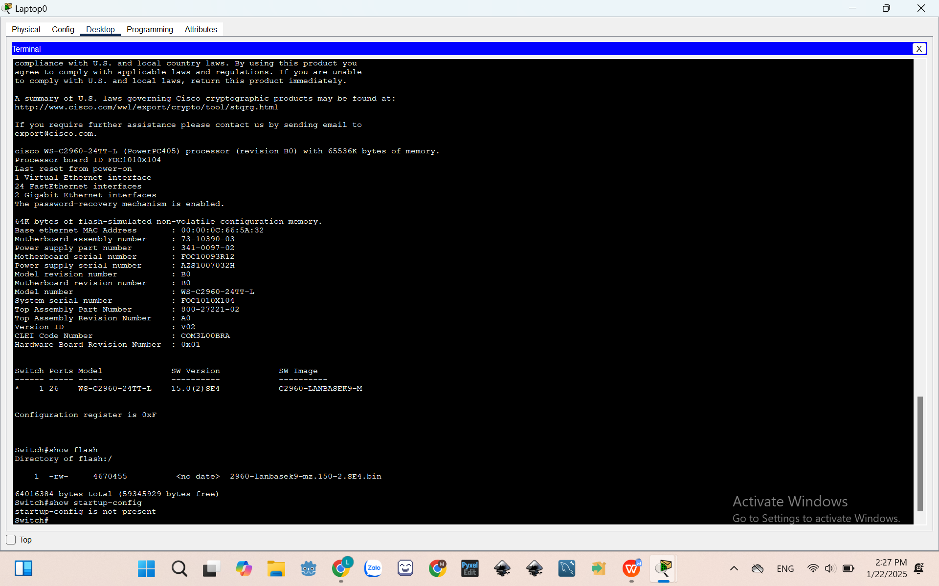
- Switch# copy running-config startup-config
- Switch# show startup-config
- Result:
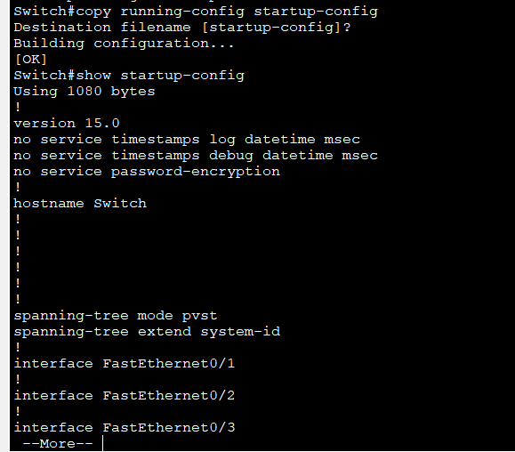
  - Configure Switch device name
- Configure hostname for Switch:
- Switch# configure terminal
- Switch(config)# hostname S1
- Result:
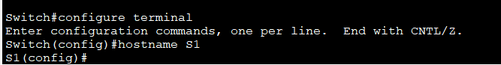
  - Configure passwords for Switch
- Configure password “cisco” for Switch:
- S1(config)# enable password cisco
- S1(config)# exit
- Result:
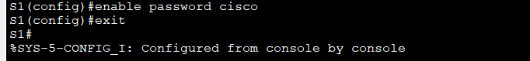
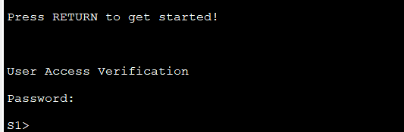
- Configure password “cisco” for Console interface
- S1(config)# line console 0
- S1(config-line)# password cisco
- S1(config-line)# login
- S1(config-line)# exit
- Result:
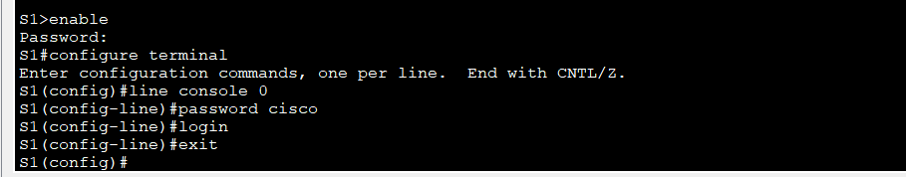

  - Configure IP for Switch
Switch is a layer 2 device which cannot be assigned an IP address. However, in order to remote access, an IP address can be assigned by using VLAN1 interface.
- Execute the following commands:
- S1#config terminal
- S1(config)# interface vlan 1
- S1(config-if)# ip address 172.10.1.10 255.255.0.0
- S1(config-if)# no shutdown
- S1(config-if)# exit
- S1(config)# ip default-gateway 172.10.1.1
- Result:
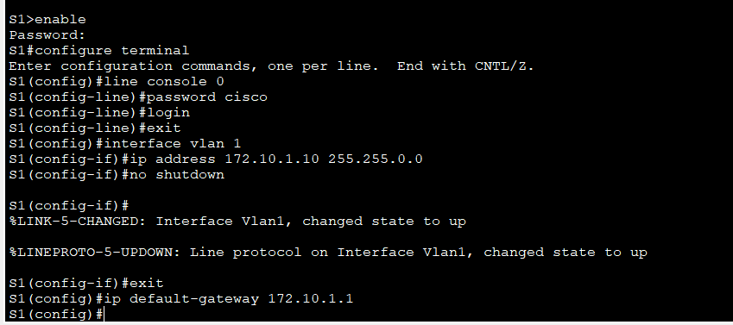
- Check configuration using the command “show running-config”. Result:
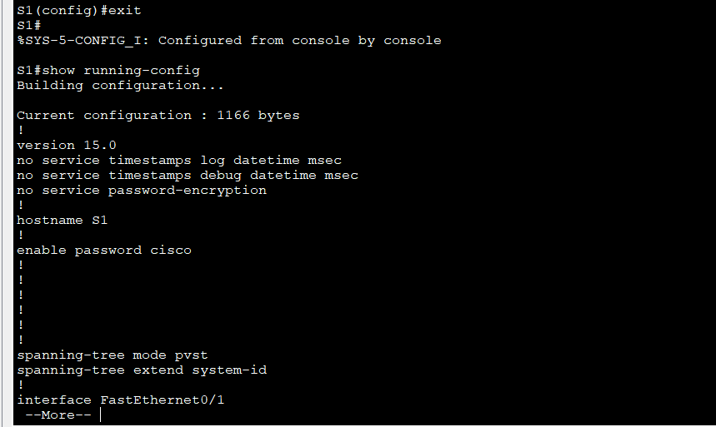
- At the PC, assign IP address to PC as follow: IP Address: 172.10.1.20, Subnet Mask 255.255.0.0. Result:
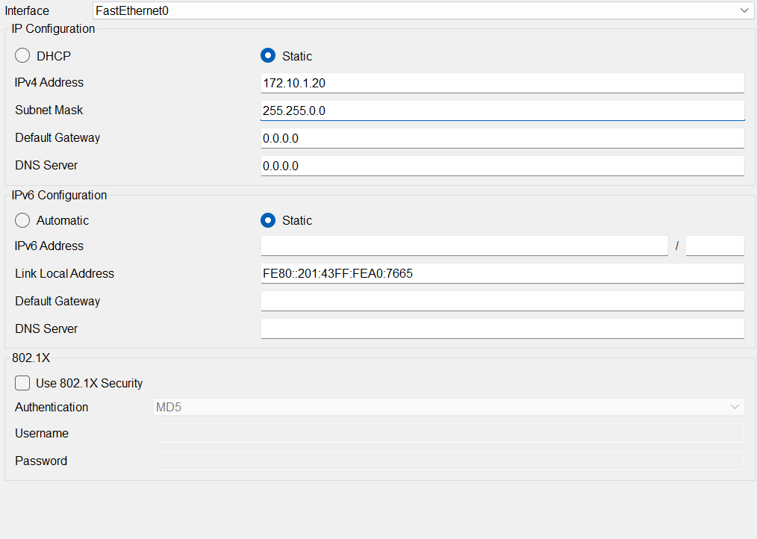
- Ping from PC to the Switch. Result:
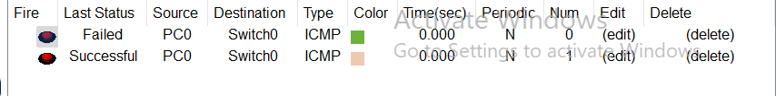

- Telnet is a service to monitor/remote using line vty. Configure password “cisco” for vty
- S1(config)# line vty 0 4
- S1(config-line)# password cisco
- S1(config-line)# login
- S1(config-line)# exit
- Result:
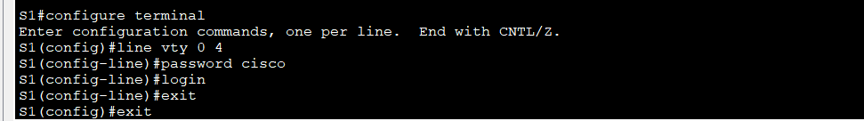
- Now, go to PC0 and open Telnet/SSH app. Choose Telnet as Connection type, then fill in the IP of Switch and click Connect:
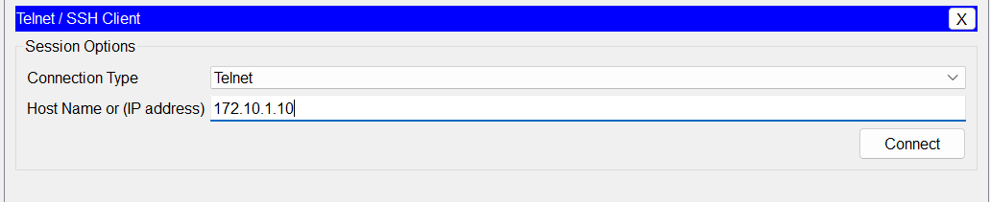
- Finally, fill in the password setup before. Result:
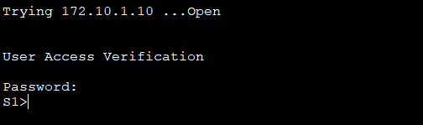

  - Change configuration at switch
- Execute the following commands:
  - S1#configure terminal
  - S1(config)#interface fastethernet 0/18
  - S1(config-if)#speed 100
  - S1(config-if)#duplex full
  - S1(config-if)#end
  - Result:
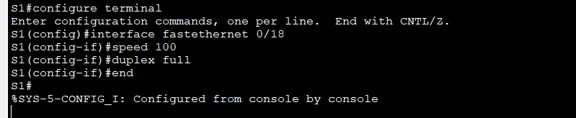
- Save configuation using the command below:
- S1#copy running-config startup-config
- Result:
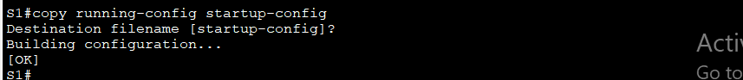
  - Show MAC table
- Execute the following commands:
  - S1#show mac-address-table
  - Result:
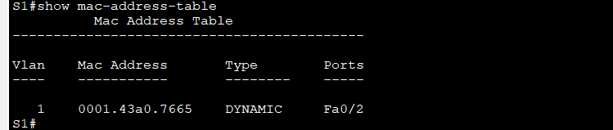
II.2 VLAN Configuration
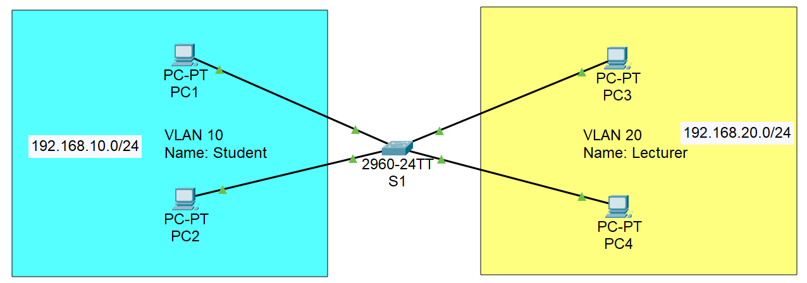
- Step 1: Assign IP for 4 PCs

- Step 2: Create 2 VLANs on Switch
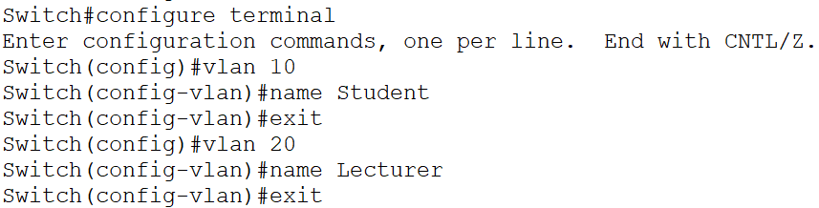
- Then, run the command “show vlan” to check the configuration. Result:
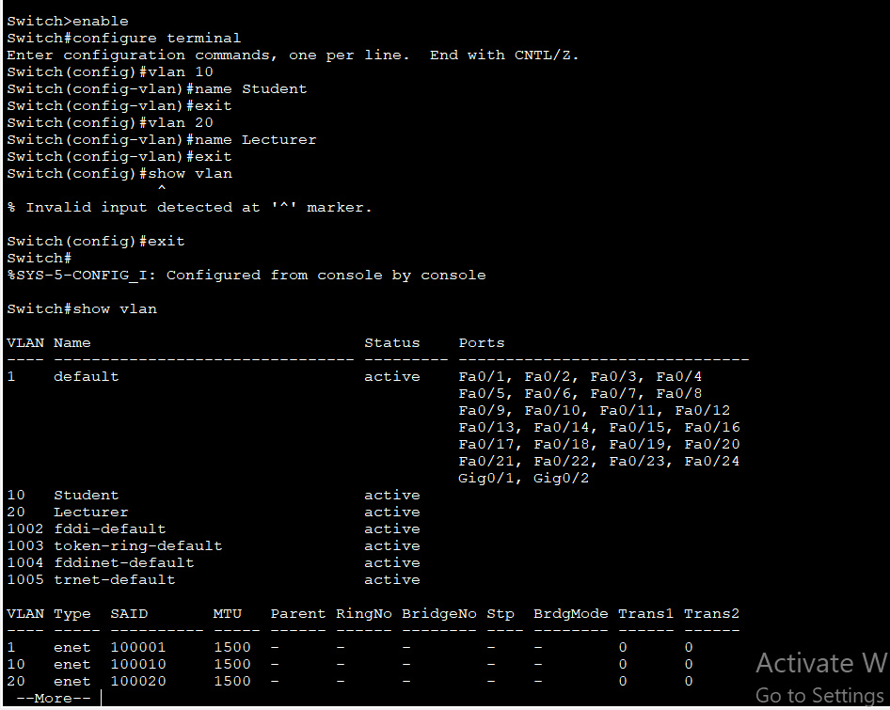
- Step 3: Assign ports to VLAN 10 and VLAN 20
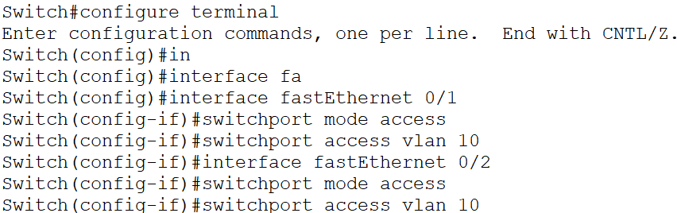
  - Repeat these steps for VLAN 20. Result:
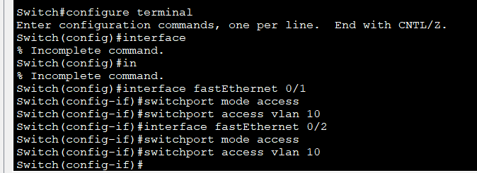
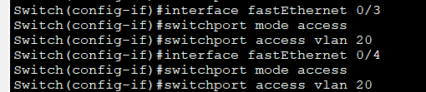
- Step 4: Check the VLAN configuration using command “show vlan”. Result:
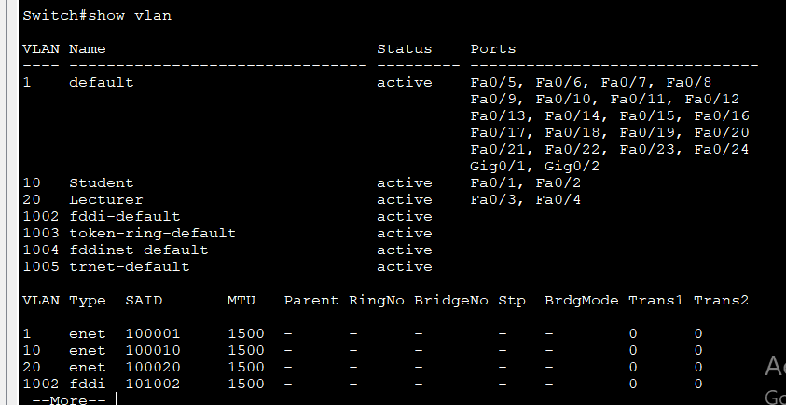
- Step 5: Check connection between PCs.
  - Ping PC1 and PC2, then explain the result. Result:
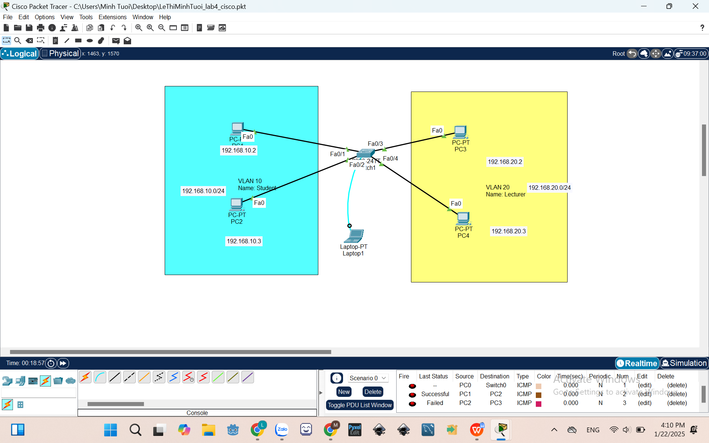
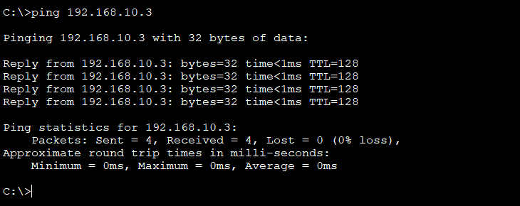
Ping is successful because PC1 and PC2 are in the same subnet.

  - Ping PC2 and PC3, then explain the result. Result:

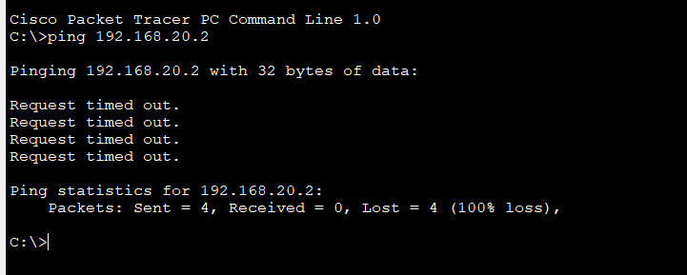
Ping is successful because PC2 and PC3 are not in the same subnet.

